K-Strings

## Description



Consider the set $S=\left\{A,B,C\right\}$ If we use this set to form two-character strings we have the following situation For each of the three possible values of the first slot we have 3 possible values for the second slot.

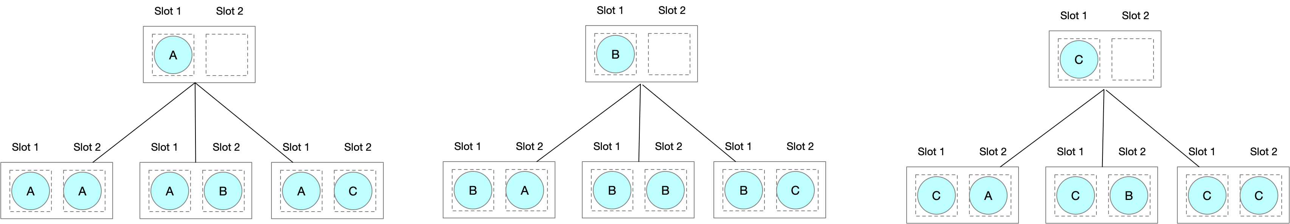

We have $3^{2}$ permutations. In full generality there are $n^{k}$ ways of forming different k-strings over a Set of size $n$.Order is important so we can think of k-strings as permutations with repetition. The following code shows how we can generate the k-strings very simply using recursion.



## Algorithm One



…\bitbucket\linqpad\Queries\algorithms\combinatorics\1.k-strings\Algorithm 1 (Iterative).linq

This algorithm is based on incrementing integers.

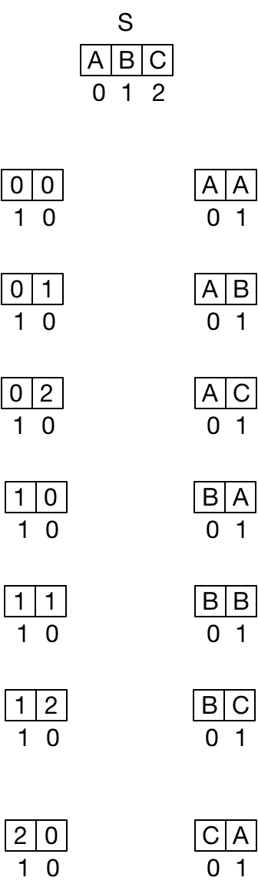

public static IEnumerable<T[]> GenerateKStrings<T>( T[] S,int kStringLength)

{

// There are n^k k-strings of a set of n items

int numKStrings = (int)Math.Pow(S.Length,kStringLength);

// Holds a k-digit number where each digit is of a base equal to

// the number of elements in the set S. So if there are two

// character in S,the digits in this number are binary.

//

// Each digit forms a index into S telling us exactly which

// element of the S forms the character at the correspondong location

// in the current kstring. So if we had k=3 and S{'a','b'} then

// a seqIndices of {0,1,1} would correspond to the k-string of

// {'a','b','c'}

int[] seqIndices = new int[kStringLength];

for (int kStringNumber = 0; kStringNumber <= numKStrings-1; kStringNumber++)

{

// Generate the current k-string by using the elements

// of seqIndices to index into S.

T[] kString = new T[kStringLength];

for (int i = 0; i < kStringLength; i++)

kString[i] = S[seqIndices[i]];

// Return the k-string.

yield return kString;

// In this algorithm we treat the indices array as an

// n-digit number where the base of each digit is determined by the

// number of elements in S.

// Moving to the next n-tuple is then a case of incrementing the

// n-digit number held in seqIndices. To this we need to take care of

// overflow which is what the following loop condition does.

int digitIdx = 0;

while (digitIdx <= seqIndices.Length - 2 && seqIndices[digitIdx] == (S.Length-1))

{

seqIndices[digitIdx] = 0;

digitIdxToIncrement++;

}

seqIndices[digitIdxToIncrement]++;

}

}

The runtime of this algorithm is clearly $n^{k}$